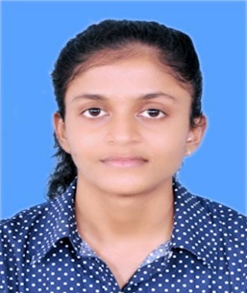 **POLWATTAGE SACHINI PAWANKA**

**PERERA**

OBJECTIVE

CONTACT

I am a hardworking and responsible undergraduate. And I

am highly enthusiastic and focused individual with right

attitude and relevant academic background.

(+94) 754 692 468

HS22096548@my.sliit.lk

56/15B, Govicam Place Road,

Divulpitiya, Boralesgamuwa.

.

ACADEMIC QUALIFICATION

**G.C.E(O/L) -2017**

BUDDHISM- A

SINHALA- A

SCIENCE- A

MATHEMATICS- A

HISTORY- A

ENGLISH- A

ICT- A

COMMERCE- A

DANCING- C

**G.C.E (A/L)- 2021**

BIOLOGY- B

CHEMISTRY- C

PHYSICS- C

GENERAL ENGLISH- B

GENERAL KNOWLEDGE- 64

LANGUAGE PROFICIENCY

* Sinhala
* English

EXTRACURRICULAR ACTIVITIES

* Member of aquatic club in Anula Vidyalaya. (2009-2017)
* Appointed as a prefect in dhamma school. (2016-2017)
* Active member in school ICT Society.
* Active member in school Astronomical Society.